

Memorandum of Understanding - MOU

For

Provision of Integrated Water Supply and Sanitation Services (IWSS) at UC-60 Lahore

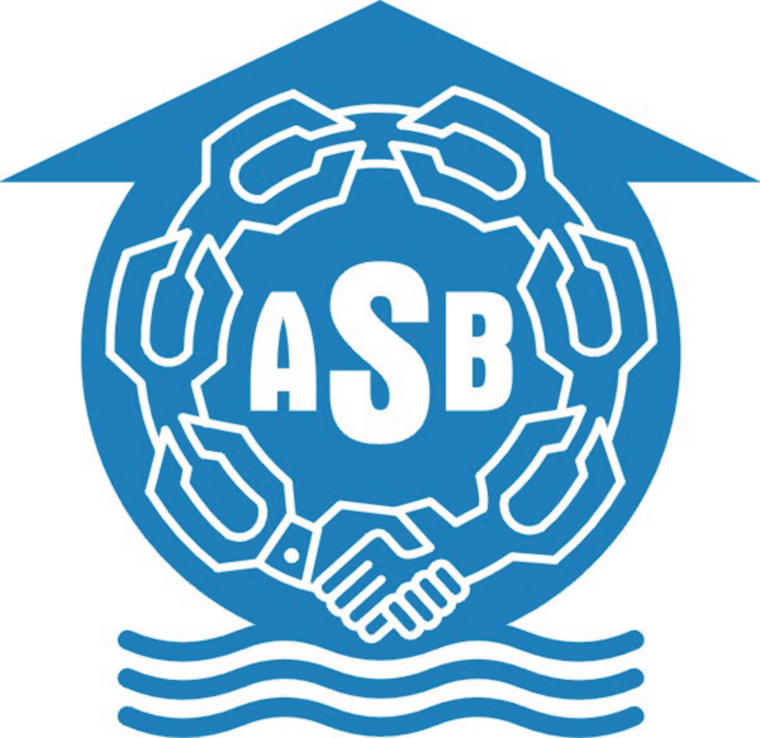

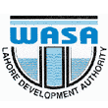

1. Background

The interaction between the water and human health are indeed complex. Human health may be affected by the ingestion of contaminated water either direct or by use if contaminated water for purposes of personal hygiene. In total it is estimated that more then 3 billion people per year die from water borne or hygiene related diseases due to unsafe drinking water, unclean domestic environment and improper excreta disposal (Helmer 1999). Government of Punjab has taken an integrated approach for the provision of water supply and sanitation through community participation on the basis of Internal and External Component Sharing Model. However, this initiative is different in a sense that Urban Unit, WASA, NGOs (Anjuman Samaji Bahbood) and Union Council 60 are joining hands for planning, designing, implementation of this project.

Projects in Orangi and in 248 locations in Pakistan have demonstrated that communities can finance, manage and built internal development as long they are encourage, organized and are provided with technical support and managerial guidance (Hasan 2006). According to the internal external model Government can support the process by building external development, provided they accept the internal – external model concept.

The partners for IWSS project will work together for the designing and implementing of an integrated water supply and sanitation project with active community component in UC-60 Lahore. The purpose of this initiative is to have a cumulative impact on low-income communities and developing a replicable model in the light of National Water and Sanitation Policy in Punjab.

2. Definition

- Internal Development for Sanitation consists of sanitary latrines inside house, underground sewers in lanes and neighborhood sewers.

- Internal Development for Water Supply consists of water supply fitting and fixtures in the house, water supply service lines and pluming work.

- External Development for Sanitation consist of trunk sewers, pumping station and treatment plant.

- External development for water supply consists of tube wells, service reservoir , transmission lines, distribution lines and water meters ( Bulk and individual).

- Partners : Urban Unit , WASA Lahore, ASB and UC 60.

- A service reservoir, a storage reservoir is a reservoir constructed as close to the consumption centre as possible to take care of the daily fluctuation in demand.
- Transmission lines are pipes that transmit raw water from source to treatment plant and treated water from treatment plants and pumping station to service provider and distribution network. The diameter is > 400mm.

- Distribution mains are pipes that carry water from transmission mains and service reservoir, and distribute it to the community. They are along streets, have several side connections They are 100 or 150 mm, and larger.

- Service Lines are small diameter pipes (<100 mm) and carry water from distribution mains to the customer premises.

The MOU will be effective from day first for one year from the signing date. Subsequent to this it will be reviewed and extended as mutually agreed between the partners after completion of the project. All the partners recognize the value of working collaboratively and would welcome any extension of this MOU to include additional partners in the future, if required.

Project Concept
The community involvement paradigm was officially adopted by the international community during 1977 World Water Conference in Mar del Plata, Argentina. The conference adopted a slogan which was “Water and Sanitation for All”. The project is based on the integrated approach of water and sanitation for UC 60 community.

This project presents an ideal opportunity for demonstrating mechanisms for improving urban services within the current institutional limitations in the light of National Sanitation Policy.

Overall Aim of the Project
Aim: Design and implementation of a water supply and sanitation project for providing efficient, reliable, affordable and environmentally sustainable system in UC 60 Lahore

3. The Partners

- The WASA Lahore is the government agency under Lahore Development Authority which is responsible for the provision of water and sanitation facilities to the citizens of Lahore.

- Anjuman Samaji Behbood (ASB) Faisalabad is a Civil Society Organization (CSO) with considerable experience of working in low income communities for providing low cost sanitation and water supply services.

- Urban Unit , Planning and Development Department is working for the strategic development of large cities of Punjab through institutional and policy reforms to convert them into sustainable cities as engines of economic growth as per Vision 2020 of Government of Punjab
- Union Council 60 Lahore as a elected community representatives in their area through their Union Council Nazim and respective councilors

4. Steering Committee

On signing of this agreement a steering committee will be formed which will meet initially at least once a month for the duration of project. WASA will act as a secretariat for the Steering Committee. The steering committee will be chaired by the WASA.

4.1. Membership
- WASA – DMD (O &M).

- Urban Unit, P&D Department, Government of Punjab –Project Director.

- UC 60 Lahore – UC Nazim.

- ASB – Coordinator Mr Nazir Ahmed Wattoo

Terms of Reference

- Coordination for successful design and implementation of the Project.

- MOU implementations.

- Conflict resolution between the partners.

- Any other matter related to project and its scope.

5. Under this MOU WASA Undertakes to :

- Design, implementation, monitoring, operation and maintenance of External Component the integrated Water Supply and Sanitation Project in UC.

- Complete financing of the hard ware of external component as defined earlier for water supply and sanitation.

- Billing of the water and sanitation services based on the metering as per Government of Punjab Terrific Policy.

- Prepare PC -1 for external component of water supply and sanitation and submit to P&D Department, Government of Punjab.
- Water quality monitoring for the project base, during and after execution of the project.

6. Under this MOU ASB Undertakes to:

- Social mobilization and capacity building of UC 60 and Community for Internal Component of Water and Sanitation.

- Advice on mapping, survey, data collection and documentation work for internal & external development.

- Support UC 60 and community for design, operation and maintenance of internal component of the WSS schemes.

- Socio economic survey.

7. Under this MOU Urban Unit Undertakes to:
I. Coordinate to build broad consensus between Partners about the Integrated Approach to WSS planning and implementation.

- Facilitate Quality Assurance for implementation of Internal and External Component of the Project.

- Facilitate Research

8. Under this MOU UC 60 Undertakes to
I. Coordinate and support ASB in their work at UC 60.

- Facilitation for Community Dialogues for components sharing approach.

- Liaison with WASA L, Urban Unit and WASB on behalf of community.

- Represent community in the Steering Committee.

V. Ensure that the community internal component finances for sharing is arranged through transparent manner

9. Management and Monitoring of the Partnership

This partnership has been forged in a spirit of joint commitment to the pressing needs for improved water and sanitation services in UC-60 Lahore. It will be managed by the partners through regular meetings of a Steering Committee.

Urban Unit WASA ASB Union Council 60

(P.D) (MD) (Coordinator) (Nazim)

